E14: Grid Subdivision

Course: IGME 309 – Real Time Simulations for Games II

Golisano College of Computing and Information Sciences

School of Interactive Games and Media

Rochester Institute of Technology

Due: Check in MyCourses

Deliverable: Single zipped file of Node.h and Node.cpp

**Objective:**

The objective of this exercise is for students to implement the **AssignIDsToEntities** function, which will assign a grid ID to each entity based on the grid nodes they are colliding with. Building on the work from the previous exercise, where the world space has already been subdivided into a grid with specific divisions along the **X**, **Y**, and **Z** axes, this task will introduce students to the process of associating entities with specific regions of space and how to efficiently track which grid cells contain which entities.

By completing this exercise, students will:

* Learn how to query the **entity manager** to retrieve all the entities within the simulated world.
* Understand how to determine which grid nodes an entity is colliding with, based on its bounding box and the subdivisions of the world space.
* Implement the **AssignIDsToEntities** function to check the **AABB** of each entity against the grid nodes and assign the appropriate grid IDs to the entities based on their collision with the grid cells.
* Develop an understanding of spatial hashing techniques, where entities are mapped to grid cells, and how this enables efficient querying and management of entities within a subdivided space.
* Explore how to optimize the process of assigning entities to grid cells, ensuring that the system can efficiently handle large numbers of entities in dynamic simulations.
* Learn the importance of spatial partitioning for improving performance in simulations and game engines, particularly when dealing with collision detection, rendering, and AI pathfinding.

This exercise will build on the concept of spatial partitioning by further dividing the world space into smaller sections (grid cells), making it possible to assign entities to specific regions of the simulation. The **AssignIDsToEntities** function is a critical step in implementing efficient spatial queries and will serve as a foundation for future optimizations and advanced spatial data structures, such as **Octrees** or **Grids**.

**Instructions:**

This exercise follows lecture D12

1. Under _Binary look for the example solution. It will look like this:

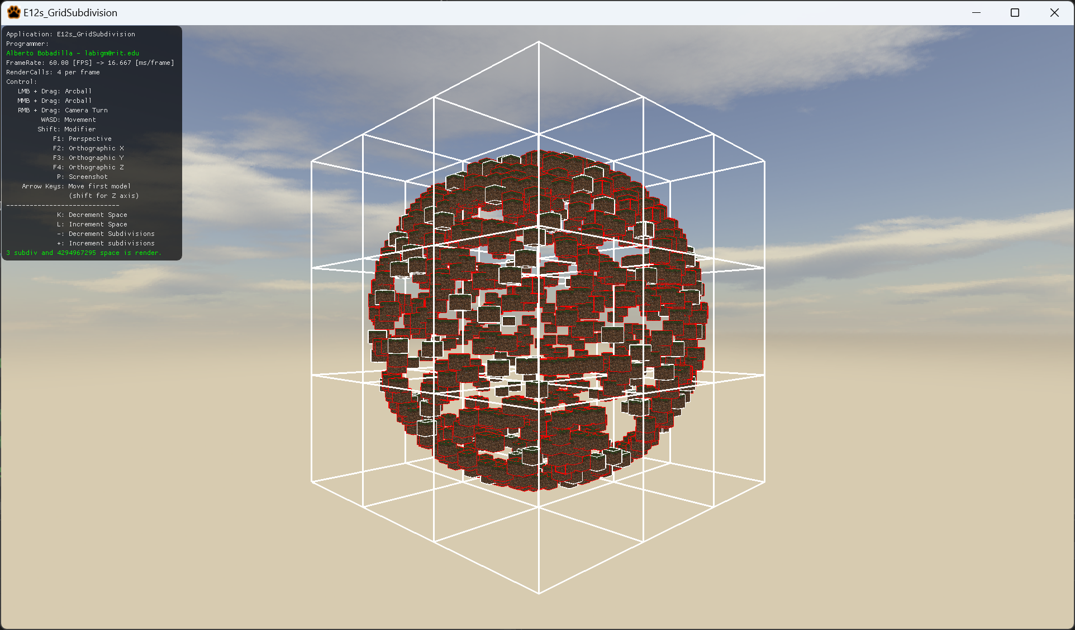

1. Out of the box the subdivision on the grid will be already functional, but the connection between the entities and the spaces is not. What you have to do in this exercise is implement the AssignIDsToEntities Method following the comments on the method.
2. This exercise only requires the Node.h and Node.cpp file for submission. You may or may not have modified the Node.h file, just to be sure, include it as well.